Software Design Report
Software Design Description
Analysis and Design
Revision:1.0
October 11, 2007
Approval
The original of this document is approved and signed by:
Name:
Surname:
Title:
Date:
Signature:
Revision History
Revision | Date | Description | Author
1.0 | October 11, 2007 | Initial version created | NA

Table of Contents
Microsoft Word users please click here and press F9 to create Table of Contents.

OpenOffice.org users please remove this text and select Insert Table of Content from menu.

Introduction

Purpose
Default value: This document describes <REP.SYSTEM_NAME> system's functionality.

Scope
NA

Overview
Section 3 Design Considerations describes major design goals, constraints and guidelines.
Section 4 Architectural Strategies describes strategies, which should be applied in order to achieve the design goals.
Section 5 System Architecture describes the architecture of the system using Conceptual view.
Section 6 Detailed Design describes design of the system in detailed models.

System Overview
Please add the data

Design Considerations

Assumptions and Dependencies
Please add the value

General Constraints
Please add the value

Goals and Guidelines
Please add the value

Architectural Strategies
Please add the value

System Architecture

Use Case View
NA

Conceptual View
NA

Deployment View
NA

Process View
NA

Detailed Design

Design Model
NA

Analysis and Design

Definition
NA

Composition
NA

Functionality and Processing
NA

Uses/Interactions
NA

Resources
NA

collaboration

Definition
NA

Composition
NA

Functionality and Processing
NA

Uses/Interactions
NA

Resources
NA

composite structure

Definition
NA

Composition
- Participant - NA

Functionality and Processing
NA

Uses/Interactions
NA

Resources
NA

conceptual perspective

Definition
NA

Composition
NA

Functionality and Processing
NA

Uses/Interactions
NA

Resources
NA

Domain Analysis

Definition
NA

Composition
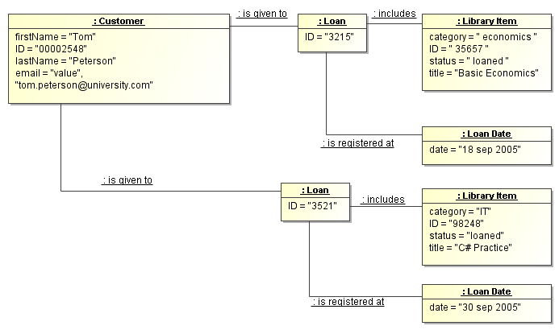
Figure 6 - Object Diagram Diagram
NA

Functionality and Processing
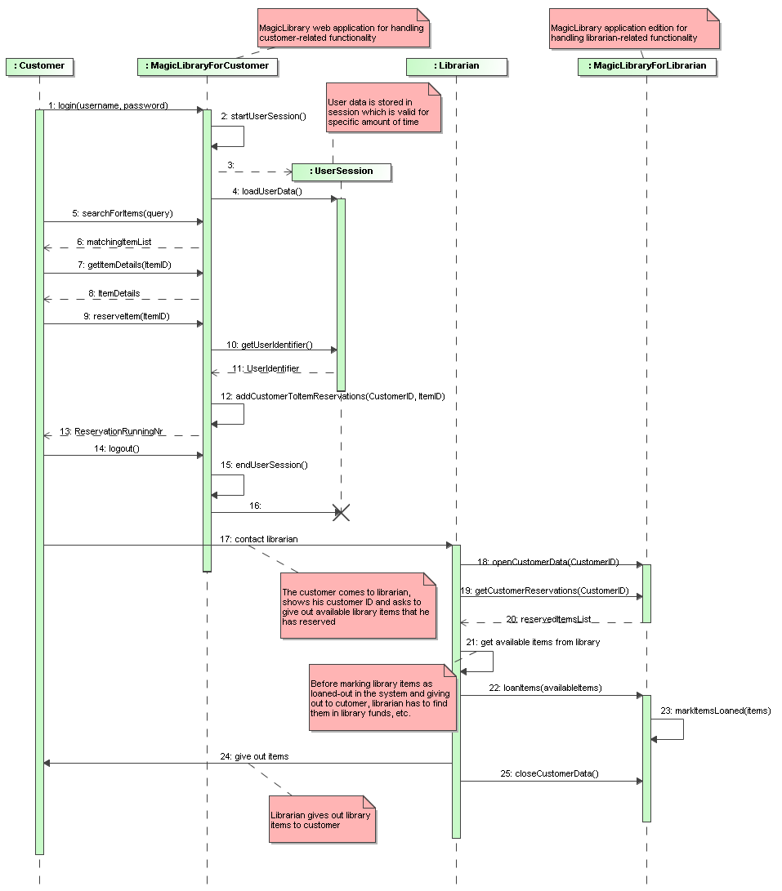
Figure 7 - Loan Library Item Diagram
NA
- 1: login(username, password)
- 2: startUserSession()
- 3: Create Message
- 4: loadUserData()
- 5: searchForItems(query)
- 6: matchingItemList
- 7: getItemDetails(ItemID)
- 8: ItemDetails
- 9: reserveItem(ItemID)
- 10: getUserIdentifier()
- 11: UserIdentifier
- 12: addCustomerToItemReservations(CustomerID, ItemID)
- 13: ReservationRunningNr
- 14: logout()
- 15: endUserSession()
- 16: Destroy Message
- 17: contact librarian
- 18: openCustomerData(CustomerID)
- 19: getCustomerReservations(CustomerID)
- 20: reservedItemsList
- 21: get available items from library
- 22: loanItems(availableItems)
- 23: markItemsLoaned(items)
- 24: give out items
- 25: closeCustomerData()

Uses/Interactions
NA

Resources
NA

Domain Design

Definition
NA

Composition
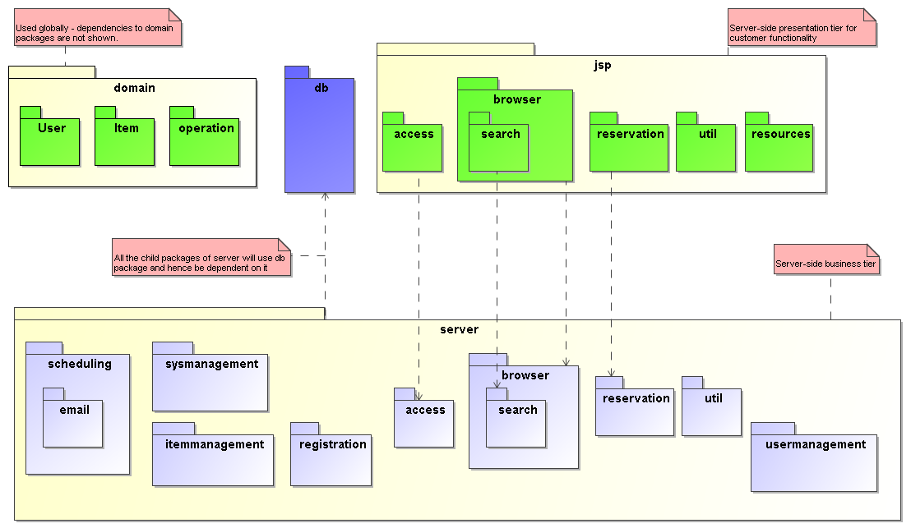
Figure 6 - Package Dependencies Diagram
NA

Functionality and Processing
NA

Uses/Interactions
NA

Resources
NA

High Level Domain Analysis

Definition
NA

Composition
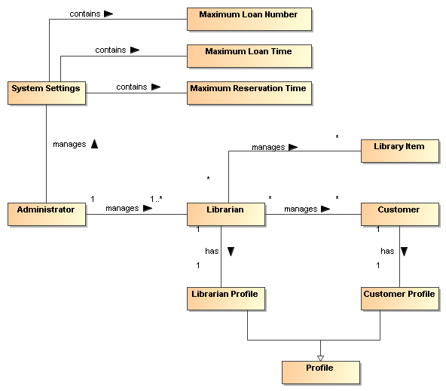
Figure 6 - conceptualPerspective1 Diagram
NA
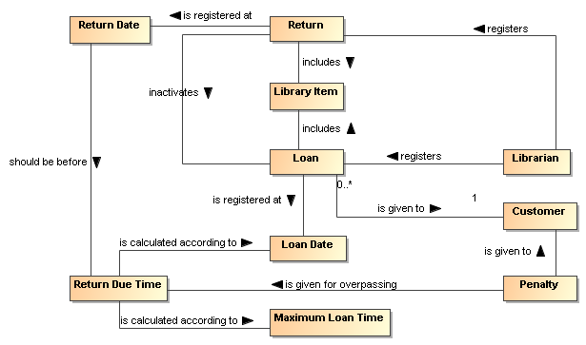
Figure 6 - conceptualPerspective2 Diagram
NA
- Penalty - NA
- Return - NA
- Customer - NA
- Return Due Time - NA
- Librarian - NA
- Maximum Loan Time - NA
- Loan Date - NA
- Library Item - NA
- Loan - NA
- Return Date - NA
- System Settings - NA
- Administrator - NA
- Librarian Profile - NA
- Customer Profile - NA
- Profile - NA
- Maximum Loan Number - NA
- Maximum Reservation Time - NA

Functionality and Processing
NA

Uses/Interactions
NA

Resources
NA

Implementation

Definition
NA

Composition
NA

Functionality and Processing
NA

Uses/Interactions
NA

Resources
NA

MagicLibrary

Definition
NA

Composition
- LibraryItems - NA
- Books - NA
- VideoRecords - NA
- AudioRecords - NA

Functionality and Processing
NA

Uses/Interactions
NA

Resources
NA

object diagram

Definition
NA

Composition
NA

Functionality and Processing
NA

Uses/Interactions
NA

Resources
NA

Technical Design

Definition
NA

Composition
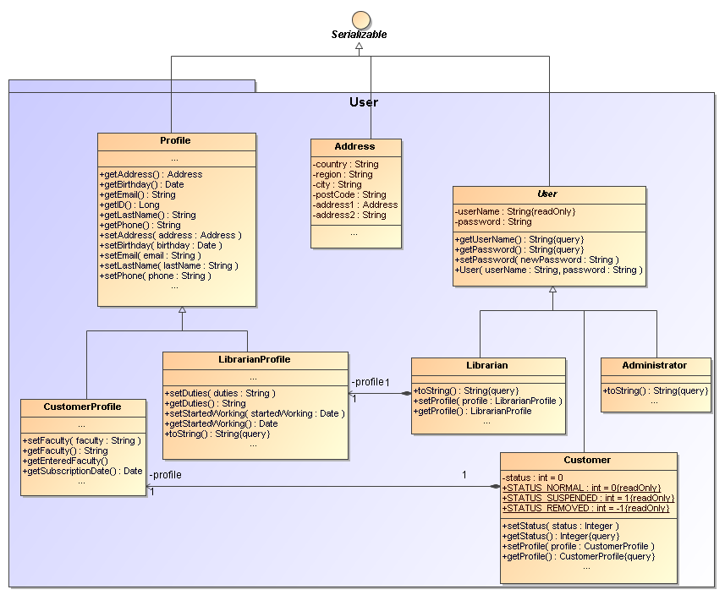
Figure 6 - domain.user Diagram
NA
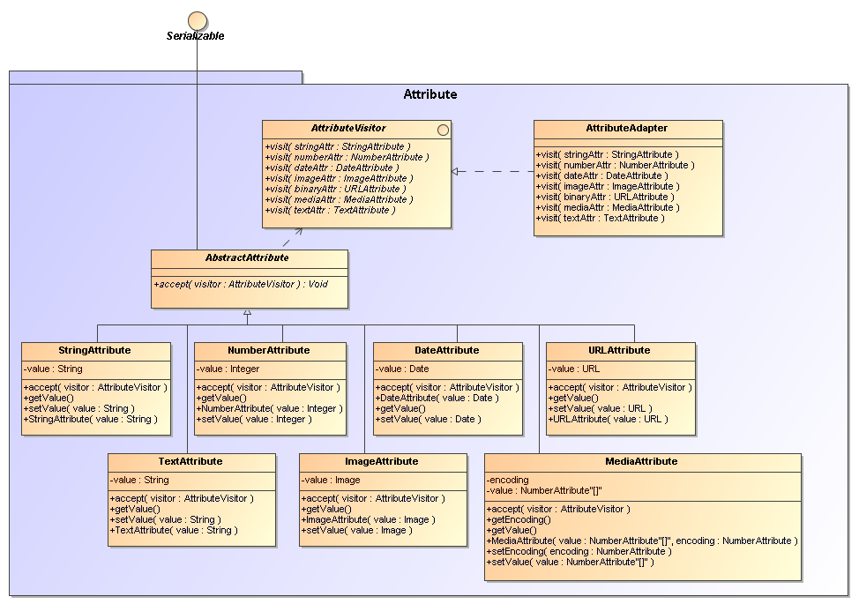
Figure 6 - domain.item.attribute Diagram
NA
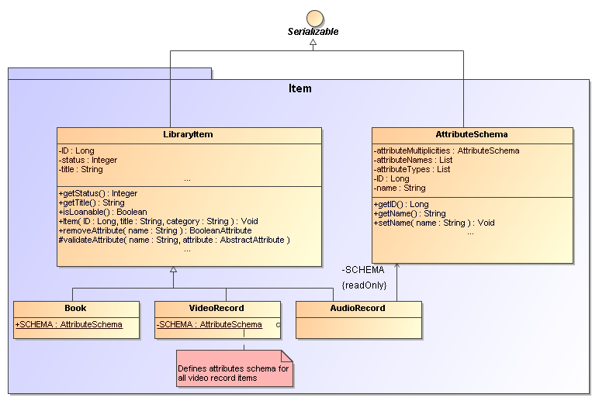
Figure 6 - domain.Item Diagram
NA

Functionality and Processing
NA

Uses/Interactions
NA

Resources
NA

Implementation Model
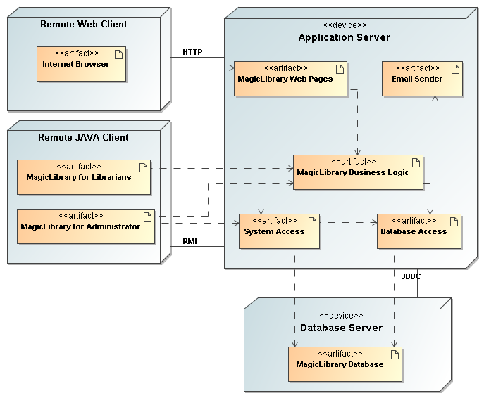
Figure 8 - Implementation Architecture Diagram
NA

